Introduction

This project will develop a web application that will provide a tool to look up product information implemented using XML. For a user to interact with these two tools, it must develop and implement a basic web page using HTML and CSS that will allow for the tool to function the Web application should be written in JavaScript, and this journal will keep information on how the project went each week and what challenge faced and how overcome those challenges.

**Week 1 Task**

During this week I was just reading and analysing what the project requirements are and asked the tutor a few questions about the project how we can structure them how many pages we need and how many files we need in the project folder such as XML, JavaScript, XSL, XML schema including the CSS and the HTML pages we also discussed on the grades of each section and what total grade would be.

Challenges

Since this is my first XML project, I was kind of confused or having difficulties with how can I build the structure of the XSL file it would be to display the XML file on an HTML page I was a bit lost with the fact that we also must use the JavaScript to display the XML file into HTML page since I have no knowledge with the JavaScript which makes it a bit hard for me to visualize how the front end would be.

Solution

I had to rewind some of the modules we did with the tutor which shows how we can build XML files and display them using XSL files. And had to go to W3 school to gain solid knowledge about XML, XSLT, and XML schema, I also had to look up some JavaScript syntax and elements to help me start my project.

**Week 2 Task**

This week involves searching for topics that go with the project requirement, which is developing, maintaining, and updating a third-party company's web application. The web application provides information on all products manufactured by the company and allows users to query the inventory for products availability.

Challenges and solutions

I had a bit of difficulty choosing what products should I implement so I had to visit some shopping websites to choose my product idea finally I had to choose shoes selling company products which I thought this idea would help me to explore more and have a successful project at the end.

The next thing I did was create an XML file using Notepad++ with elements of Category, name, Code, Quantity, and Unit Price, I also had to add the image element to display the images which will make the application user-friendly and clearer. I Created 15 products in total to have more accessibility in my application at the end. I also created three HTML pages that will display and search products along with the Contact Us page.

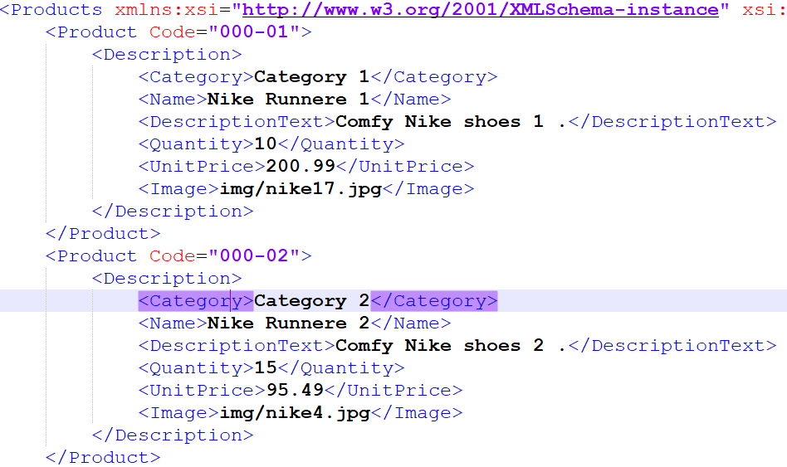

**Week 3 Task**

The next task was creating an XSL file to connect the XML file with XSLT to be able to display the products on the web with the structure that the XSL file has, I also had to create a JavaScript that managed the connection between XML and Xslt and displaying the product on the page

The JS blow is a function to check the browser if it supports the **XML HTTP Request object** and then it will create an instance otherwise it will use the **ActiveX Object** which is the older version of Internet Explorer.

The second function will be called to display the XML file but before that, it will connect the XML with the XSLT file, it will use **transformNode** to transform the XML file when the JS is called window. onload event will make sure that the process occurs on the page.

Challenge and solution

The challenge I faced was the product couldn’t be able to be displayed on the page for some security reasons, so I had to connect it with the local host, I downloaded the XAMPP control panel and used Apache.

next move was to try if the code was working using: [http://localhost/xmlTest/productList.html through a web browser.a](http://localhost/xmlTest/productList.html%20through%20a%20web%20browser.a) as you can see below it worked perfectly.

**Week 4 Task**

In this week I focused on the search page which I want to access the product using Code (ID) or Name using the XPath Expression that is shown in the picture below.

I created an XML schema to set a rule for how the data is organized in an XML file, it will help us to prevent some errors by making sure the data is flowing in some format and it will share information easily between different systems.

**Challenge and solution:** I was having some difficulties with not being able to update the XML file or the JavaScript because the local host was trying to save previous code and displaying it again and again whether the code was updated or not. to solve this problem, I had to do some research regarding deleting browsing data. I found out **Shift + CTRL** can play the option to clear all the data as you can see below.

**Week Five Task**

In this part, I spent time making the HTML pages look good with CSS. However, I ran into problems, especially with the index and Contact Us pages because of some issues with CSS. To fix this, I had to make a separate CSS just for the Contact Us page. It was a bit tough but creating a dedicated CSS for that page helped sort things out and make it look better. This part was all about making sure the pages look nice and work well.

**Conclusion:**

Week Five marks a big step in the project. From learning about XML, XSLT, and JavaScript to building a working web application, it's been a journey. Dealing with challenges, like the security problem that stopped the products from showing, led to finding solutions, like using XAMPP and connecting to localhost.

Choosing products, creating XML files, and building HTML pages not only showed what I can do technically but also how I understand what users need. Adding an XML schema to organize data was about keeping things in order. Dealing with issues updating files because of local host stuff was tricky but figuring out how to clear browsing data helped.

This project isn't just about coding. It's about problem-solving and sticking with it. As it goes on, I know there will be more to learn and fix. Looking back, it's clear how much progress has been made each week. Understanding XML, XSLT, JavaScript, and all that techie stuff is going to be handy for whatever comes in the future.

Top of Form